**Project Report**

Big Mountain resort is looking for option of either cutting the costs or increasing the revenue by setting the new ticket price. Based on different Business scenarios, below are my recommendation for Big Mountain resort.

Business is planning to incorporate some changes like closing some of the not used runs, increasing the longest run by some miles and may be increasing the vertical drop.

Based on my analysis, Big Mountain resort can permanently close up to 5 least used runs. Because closing more than 5 runs will lead to larger drop in revenue. Attaching plot below to support my recommendation:

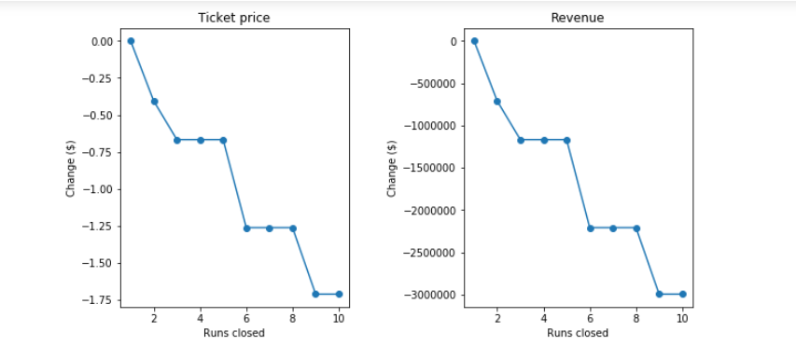

From above plot we can see that, closing more than 5 runs have drastic effect on revenue.